امتحان lesson 1 اذا كانت النقاط 1 2 3 … تكون الاختيارات a b c …
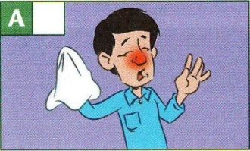
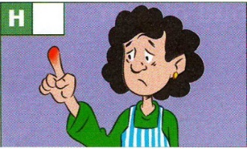
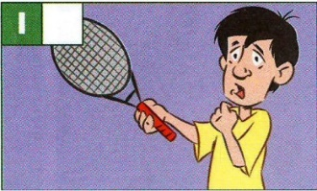
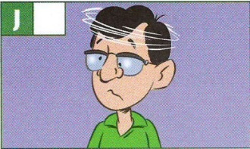
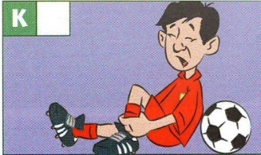
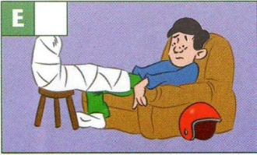
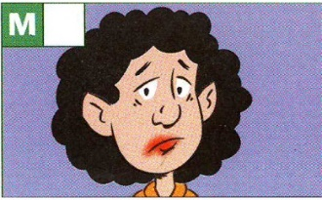
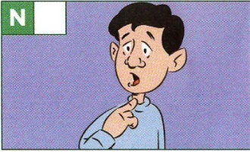
- I have a very bad cold. I can't stop __________ .
(sprained , sneezing , broken)
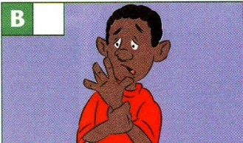
- I've got a bad wrist. I __________ it lifting weights in the gym.
(pain , fractured , sprained)
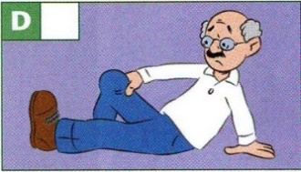
- I've got a pain in my knee. It's really __________.
(swollen , hurts , pain)
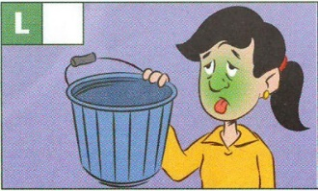
- I've got a broken leg. I __________ it in a motorbike accident.
(broken , sneezing , fractured)
- My back __________ all the time. It only feels OK when I am lying down.
(swollen , hurts , sprained)
- She can't play tennis. She has __________ her right arm.
(sneezing , pain , broken)
- Where exactly is the __________ and how long have you had it?
(pain , fractured , sprained)

- joint in the arm. __________
(wrist , cream , ankle)
- inside the body, __________
(skin , joint , bones)
- bandage , treatment, ankle , __________
(verb , outside the body , joint)

امتحان lesson 2 اذا كانت النقاط 1 2 3 … تكون الاختيارات a b c …

- As I _________ where I was going , I _________ my car into a tree.
(didn’t look …….. was crashing , wasn't looking …….. crashed)
- I _________ ready for school and it _________ to rain.
(was getting …….. started , got …….. was starting)
- When my brother _________ his leg , he _________ football.
(played …….. was hurting , hurt …….. was playing)
- While I _________ for the bus, I _________ an amazing car.
(waited …….. was seeing , was waiting …….. saw)
- I _________ about the football match when the teacher _________ at me.
(was thinking …….. shouted , thought …….. was shouting)

امتحان lesson 3 اذا كانت النقاط 1 2 3 … تكون الاختيارات a b c …
- Where did Zaid go on his holiday?
- To the hospital
- To Sharm El Sheikh in Egypt
- To Iraq

- What did the shark do to Tariq?
- The shark bit his arm.
- The shark killed Tariq.
- The shark saved Zaid.

- What was Zaid Tariq doing when he saw the Shark
- He was lying in the boat.
- He was in Egypt.
- He was lying on an airbed.

- What saved Tariq?
- Two children.
- Six dolphins.
- The shark.

- What did the dolphins do to the shark?
- bit the shark.
- frightened the shark away.
- bit Tariq

- Where was Tariq taken?
- To Iraq
- To the hospital.
- To the hotel

- She was very __________ when she saw a snake.
)frightened , frightening(

- This man is a very __________ person. He has great stories.
)interested , interesting(

- The old man was a very __________ driver on the roads.
(careful , carefully)

- The story was very _________ ended.
(awful , awfully)

